Predicting Smartphone Addiction Through Deep Learning
A Capstone Project report submitted
in partial fulfillment of requirement for the award of degree
BACHELOR OF TECHNOLOGY
in
SCHOOL OF COMPUTER SCIENCE AND ARTIFICIAL INTELLIGENCE
by
K.Manush | (2203A51081)
M.Vedasree | (2203A51371)
A.Nithin Chandra | (2203A51701)
B.Shiva Sahithi | (2203A51718)
G.Raviteja | (2203A51721)

Under the guidance of
Mr. S. Naresh Kumar
Assistant / Associate / Professor, School of CS&AI.

SR University, Ananthsagar, Warangal, Telagnana-506371

SR University
Ananthasagar, Warangal.


CERTIFICATE
This is to certify that this project entitled “Predicting Smartphone Addiction Through Deep Learning" is the bonafied work carried out by K. Manush, M. Vedasree, A. Nithin Chandra, B. Shiva Sahithi, G. Raviteja as a Capstone Project for the partial fulfillment to awardthe degree BACHELOR OF TECHNOLOGY in School of ComputerScience and Artificial Intelligence during the academic year 2024-2025 under our guidance and Supervision.

Mr. S. Naresh Kumar | Dr. M.Sheshikala
Designation, | Professor & Head,
SR University | School of CS&AI,
Anathasagar,Warangal | SR University Ananthasagar, Warangal.
Reviewer-1 | Reviewer-2
Name: | Name:
Designation: | Designation:
Signature: | Signature:

ACKNOWLEDGEMEN

We owe an enormous debt of gratitude to our Capstone project guide Mr. S. Naresh Kumar,
Asst.Prof./Assoc Prof/Professor as well as Head of the School of CS&AI , Dr. M.Sheshikala, Professor and Dean of the School of CS&AI, Dr.Indrajeet Gupta Professor for guiding us from the beginning through the end of the Capstone Project with their intellectual advices and insightful suggestions. We truly value their consistent feedback on our progress, which was always constructive and encouraging and ultimately drove us to the right direction.
We express our thanks to project co-ordinators Mr. Sallauddin Md, Asst. Prof., and R.Ashok Asst. Prof. for their encouragement and support.
Finally, we express our thanks to all the teaching and non-teaching staff of the department for their suggestions and timely support.

TABLE OF CONTENT

S.No | Content | Page No
1 | INTRODUCTION | 1 - 2
2 | PROBLEM STATEMENT | 3
3 | LITERATURE REVIEW | 3 - 9
4 | REQUIREMENT ANALYSIS | 9 - 14
5 | RISK ANALYSIS | 14 - 19
7 | FEASIBILITY ANALYSIS | 20 - 23
8 | P PROPOSED METHODOLOGY | 23 - 24
9 | SYSTEM DESIGN AND ARCHITECTURE | 25 - 26
10 | ALGORITHMS USED | 26 - 30
11 | RESULT AND DISCUSSUION | 30 - 33
12 | CONCLUSION | 33 - 34
13 | FUTURE SCOPE | 34 - 36
14 | REFERENCES | 36 - 37

ABSTRACT

The project will focus on predicting and estimating the addiction to smartphones by applying the methods of deep learning by studying real-time eye activity instead of the traditional methods of statistics of phone use. Using the data in the form of algorithms to work with the characteristics of blink frequency, duration, variability, and eye-state classification, in conjunction with the data regarding user sessions will allow the system to go beyond simple screen-time metrics and capture behavioural and cognitive indicators of overuse. Using live camera feeds and model lightweight landmark finding and eye state classification models such as Retina Face and MobileNetV2, the project assembles a complete pipeline that identifies features and deferrals them to a multilayer perceptron (MLP) to predict the estimate degree of addiction risk.
The methodology will consist of Data preprocessing, eye-region cropping, normalisation, feature engineering and model training and evaluation. Various machine-learning methods, such as the classification of eye states, and regression-type predicting risk scores are compared to identify the most effective method to predict smartphone addiction. The system also provides prompt feedback and recommendations given in a personalised manner to promote healthier screen habits.
On the whole, the project makes a contribution to the expanding sphere of digital-wellness analytics by utilizing artificial intelligence and machine learning to forecast the risk of addiction to the smartphone and, thus, develop the body of knowledge concerning the relevance of using the mobile phone in a healthy way and allowing people to maintain healthier relationships with their technological devices.

Index Terms—Keywords— Deep Learning, Smartphone Addiction Prediction, Real-Time Eye
Tracking, Blink Pattern Analysis, Eye Landmark Detection, MobileNetV2, Multilayer Perceptron, Digital Wellness Analytics, Behavioural Monitoring, Health Risk Prediction, Artificial Intelligence in Human Behaviour.

II. INTRODUCTION

Smartphones are a life necessity in the contemporary digital world. They are not merely communication devices, but they also have more than one other use as learning devices, socializing devices, and entertainment devices along with work tools. The high consumption of smartphones has transformed lifestyle, education and work force of individuals in a massive way. Although these devices are associated with endless comforts, numerous difficulties have been associated with their overuse or misuse. Studies will tend to link increased use of smartphones with the irritation of eye, mental exhaustion, loss of concentration, and behavioral addiction. These effects can interfere with their cognition, creative abilities, productivity, and wellbeing among young adults, professionals and students who use the devices extensively.
The existing smartphone monitoring tools (screen-time tracking apps or usage statistics) provide a cursory understanding of the behavior of users. They measure the amount of time they spend on applications or devices but fail to get the physiological or cognitive indicators of overuse. This weakness suggests that many individuals are unaware of the f irst signs of addiction, and they struggle to manage their addiction to the smartphone. Recent research shows that physiological signs are also excellent, particularly the eye movement, which is a good measure of excessive use of technology in smartphones. The eye dynamics including frequency of blinking, duration of blinking and disorganized blinking have been determined as being correlated with fatigue, cognitive load and levels of mental stress. Such indicators in contrast to the usage statistics provide a direct physiological indicator of the state of the mind of the user hence providing a more accurate parameter of the potential of addiction of a smartphone user. The current systems have their own major disadvantages irrespective of the likelihood of monitoring eye activity. They may have hardware specifications, they may be computationally intensive and they may not be capable of running continuously on a mobile device. This creates an imbalance between the desired, actual, user friendly, and easily available monitoring system and the existing technologies. To address this gap, a deep learning-based model is proposed in the given study to offer the prediction of smartphone addiction in real-time eye tracking. Live camera images of the device are always captured and used to identify facial features and eye features and identify eye conditions (e.g. an open or a closed eye). It identifies the important parameters of blink such as frequency, duration and irregularity. These measures are fed into a multilayer perceptron (MLP) model which decomposes the data to find out the probability of the user to be addicted to his or her smartphone. The system can provide real time feedback and personalized recommendations in response to the output to change people to become healthier smart phone users. The framework combines both deep learning and lightweight image processing algorithms and hence can be scaled making it automated and can be applied in continuous observation of mobile devices. It is not limited to personal uses applications, it can be implemented in safety and health-monitoring applications in the working environment. As an illustration, one can use eye monitoring to show how alert drivers are, effectively monitor employees working in stress-inducing environments, or to establish whether early mental fatigue has occurred to provide some of the necessary elements needed to develop preventative health programs. The approach is filling the gap that the traditional screen time apps have caused, as it involves the incorporation of the real-time tracking of the physiological functions, along with the predictive and long-term modeling. Users are taught to be aware of behavioral patterns and recognize at the initial stages when they are over-using digital devices and take steps as a preventive measure to stay digitally healthy. Moreover, the system has contributed to the creation of intelligent personal assistances and digital health technologies, as it tries to overcome the borderline between the sphere of physiology and machine learning and the sphere of the practice of application of a mobile phone. Lastly, this project is aimed at assisting individuals and organizations in managing the smartphone utilization and grow more efficient besides aiding in preserving the mental and physical well-being. It has transformed the manner in which we are interacting with the technology and made the smartphone usage safer, smarter, and more balanced through providing an actionable, user-friendly, and real-time solution.

- PROBLEM STATEMENT
The long-term use of smartphones has gradually turned into a cause of digital addiction, stress, and lack of concentration with a harmful effect on cognitive abilities and overall productivity. The more time people spend on their gadgets, the more they tend to overlook the fact that their habits of use affect the mental state. The self-regulation process is hard and many users have no clue about the subtle signs of overuse and their behavior, and thus unhealthy habits develop without any significant notice.
Current smartphone wellness apps do not measure anything beyond the screen time or app usage. Although they are helpful, these measures do not give a vivid picture of the online activity of a user and cannot define the degree of addiction accurately. They do not have the capacity to study more behavioral clues related to compulsive smartphone use.
A deep learning-based system can be significant to fill this gap. With the ability to capture intricate behavioral patterns and suggest meaningful insights by examining them using advanced models, such a system will be able to classify addiction levels more accurately. Moreover, it is capable of delivering tailored suggestions that will lead users to healthier online lifestyle choices, fostering the improvement of their mental health and more moderate smartphone usage.

IV. LITERATURE REVIEW

- Nijkamp proposed a machine learning approach for identi fying addictive smartphone behaviors using usage logs such as daily screen time, application frequency, and session dura tions. Although the models provided initial insights, the study emphasized that behavioral data alone are insufficient to detect early addiction. [1].
- Real time eye blink using general cameras with facial land marks approach (2023) With the assistance of the ordinary webcams and facial landmarks identification (with EAR), Lu Youwei invented a blink-detection algorithm, which monitored blinks in various background and lighting settings. It is live time and has been tested on different settings and it has concluded that the only thing required in blink-based surveillance is generic cameras and they do not need any special equipment. isg-journal.com [2].
- CNN Drowsiness Level Eye Blink Detection to maintain Road Safety among the Drivers (2024) The convolutional neural network (MobileNetV2 base) used in this paper to determine the eye blinks and hence estimate the state of drowsiness. Pre-processing includes the use of dlib facial landmarks and the training is performed with the help of binary cross entropy loss. They detect the blink with an approximation of 97+1 [3].
- 3D-Landmarks Camera-based Blink Detection (iWOAR 22). The researcher in this paper suggests how the detection of blink can be done on a webcam picture by utilizing the 3D facial features as a means of detecting the blink amongst computer users who spend long hours on the computer. The authors compare publicly available blink databases, describe their 3D-landmark strategy, and remark on the accuracy/robustness in the situations of different scenarios. Their work also involves the blink interventions (warnings) concerning eye strain. ACM Digital Library + [4].
- Intelligent Standalone Eye Blinking Monitoring System for Computer Users (2024) This system is designed especially for computer users to monitor blinking patterns and issue personalized alerts when blink rate drops (which may indicate digital eye strain). It uses video capture, blink detection, and a user-alarm mechanism. The study reports high accuracy in blink detection and evaluates user comfort improvements.bop.unibe.ch [5].
- ImageProcessing algorithms performance analysis of eye blinking detecting algorithms (2023)This paper explains the eye blink detection algorithms in different video formats, their performance, their cost and usability in low resource setting. It compares the RGB and grayscale input and evaluates the different lighting analysis and the rate of detection. Their findings contribute to the determination of what of more basic image-processing mechanisms continue to be effective in real life. Science Direct [6].
- Eye Blink Detection System to dry eye syndrome and its performance model (2018). Govardhane and Wyawahare suggest using a webcam-based mechanism so that the blink rate is tracked at all times to aid in diagnosing or preventing Dry Eye Syndrome. The system provides an alert when a defined rate of blink is below it. Their other model is a performance model that connects the system accuracy to all sorts of environmental and user variables; their accuracy is approximately 90SpringerLink [7].
- Hong, Yun, Xing Rong, and Wei Liu. "Construction of influencing factor segmentation and intelligent prediction model of college students' cell phone addiction model based on machine learning algorithm." Heliyon 10.8 (2024)[8].
- Likhith , S., et al. "Machine Learning Model for Prediction of Smartphone Addiction." 2024 International Conference on Expert Clouds and Applications (ICOECA). IEEE, 2024[9].
- Giraldo-Jiménez, Claudia Fernanda, et al. "Smartphones dependency risk analysis using machine-learning predictive models." Scientific Reports 12.1 (2022): 22649[10].
- Lee, Juyeong, and Woosung Kim. "Prediction of problematic smartphone use: A machine learning approach." International journal of environmental research and public health 18.12 (2021): 6458[11].
- Kim, Kyungwon, Yoewon Yoon, and Soomin Shin. "Explainable prediction of problematic smartphone use among South Korea's children and adolescents using a Machine learning approach." International journal of medical informatics 186 (2024): 105441[12].
- Joseph, C., and P. Uma Maheswari. "Facial emotion based smartphone addiction detection and prevention using deep learning and video based learning." Scientific Reports 15.1 (2025): 18025[13].
- Beluli, Alma. "Machine Learning-Based Prediction Model for the Measurement of Mobile Addiction." Designing and Developing Innovative Mobile Applications. IGI Global, 2023. 56-66[14].
- Selvalakshmi, G., and H. Benjamin Fredrick David. "Analysis and Study of Mobile Phone Addiction in the context of Artificial Intelligence"[15].
- Zhou, Yongjie, et al. "Predictors of smartphone addiction in adolescents with depression: combing the machine learning and moderated mediation model approach." Behaviour Research and Therapy 189 (2025): 104749[16].
- Kim, Kyungwon, Yoewon Yoon, and Soomin Shin. "Explainable prediction of problematic smartphone use among South Korea's children and adolescents using a Machine learning approach." International journal of medical informatics 186 (2024): 105441[17].
- Beluli, Alma. "Machine Learning-Based Prediction Model for the Measurement of Mobile Addiction." Designing and Developing Innovative Mobile Applications. IGI Global, 2023. 56-66[18].
- Raj, A. D., et al. "Machine Learning Model for Prediction of Smartphone Addiction." Indiana Journal of Multidisciplinary Research 4.3 (2024): 104[19].
- Giraldo-Jiménez, Claudia F., et al. "Machine-learning predictive models for dependency on smartphones based on risk factors." (2021)[20].
- Yau, Shuaibu, Abdulsalam Abdulganiyu Ishola, and Abdu Ibrahim Adamu. "Predicting the Effect of Mobile Phone on Student Academic Performance Using Machine Learning." Int. J. Sci. Res. in Computer Science and Engineering Vol 12.5 (2024)[21].
- Pawar, Vivekanand, Archana Bhaskar Patil, and Aparna Santra. "Predicting Smartphone Addiction Using Behavioral and Psychological Traits with Machine Learning." 2025 Global Conference in Emerging Technology (GINOTECH). IEEE, 2025[22].
- Namlı, Sevinç, et al. "The Relationship Between Smartphone and Game Addiction, Leisure Time Management, and the Enjoyment of Physical Activity: A Comparison of Regression Analysis and Machine Learning Models." Healthcare. Vol. 13. No. 15. MDPI, 2025[23].
- Uz Zaman, Nur, et al. An approach to detect smartphone addiction through activity recognition and app usage behaviour. Diss. Brac University, 2023[24].
- Achal, Fairuz Tanzim, Mosammat Suraiya Ahmmed, and Tanjim Taharat Aurpa. "Severity detection of problematic smartphone usage (PSU) and its effect on human lifestyle using machine learning." 2023 IEEE 8th International Conference for Convergence in Technology (I2CT). IEEE, 2023[25].
- Alruban, Abdulrahman. "Prediction of application usage on smartphones via deep learning." IEEE Access 10 (2022): 49198-49206[26].
- Yalman, Ayşen, et al. "Predicting Phubbing Through Machine Learning: A Study of Internet Usage and Health Risks." Applied Sciences 15.3 (2025): 1157[27].
- Gezgin, Deniz Mertkan, et al. "The role of self‐regulated learning in modelling the relationships between learning approaches, FoMO and smartphone addiction among university students." British Journal of Educational Technology (2025)[28].
- Rao, P. Yaswanth. "40 Prediction of smartphone addiction using ensemble algorithm." Synergies in Smart and Virtual Systems Using Computational Intelligence (2025): 226[29].
- Ronao, Charissa Ann, and Sung-Bae Cho. "Human activity recognition with smartphone sensors using deep learning neural networks." Expert systems with applications 59 (2016): 235-244[30].
- Abo-Tabik, Maryam, et al. "Towards a smart smoking cessation app: A 1D-CNN model predicting smoking events." Sensors 20.4 (2020): 1099[31].
- Thakur, Saurabh Singh, Pradeep Poddar, and Ram Babu Roy. "Real-time prediction of smoking activity using machine learning based multi-class classification model." Multimedia tools and applications 81.10 (2022): 14529-14551[32].
- Sun, Yilin, et al. "Machine-learning approaches to identify travel modes using smartphone-assisted survey and map application programming interface." Transportation research record 2677.2 (2023): 385-400[33].
- Wang, Jing, et al. "Spatiotemporal modeling and prediction in cellular networks: A big data enabled deep learning approach." IEEE INFOCOM 2017-IEEE conference on computer communications. IEEE, 2017[34].
- Arora, Anshika, Pinaki Chakraborty, and M. P. S. Bhatia. "Optimizing Smartphone Addiction Questionnaires with Smartphone Application and Soft Computing: An Intelligent Smartphone Usage Behavior Assessment Model." Soft Computing Techniques in Connected Healthcare Systems. CRC Press, 2023. 17-33[35].
- Chen, Yu-Chun, et al. "Are you killing time? Predicting smartphone users’ time-killing moments via fusion of smartphone sensor data and screenshots." Proceedings of the 2023 CHI Conference on Human Factors in Computing Systems. 2023[36].
- Ballal, Ishaan Pradip, and Kanika Prasad Nadkarni. "Data analysis and prediction of survey on effect of smart phones on society." Emerging Trends in Electrical, Communications, and Information Technologies: Proceedings of ICECIT-2018. Singapore: Springer Singapore, 2019. 61-70[37].
- Cha, Seong-Soo, and Bo-Kyung Seo. "Smartphone use and smartphone addiction in middle school students in Korea: Prevalence, social networking service, and game use." Health psychology open 5.1 (2018): 2055102918755046[38].
- Kim, Jina, et al. "A deep hybrid learning model for customer repurchase behavior." Journal of Retailing and Consumer Services 59 (2021): 102381[39].
- Yin, Xueyan, et al. "Deep learning on traffic prediction: Methods, analysis, and future directions." IEEE Transactions on Intelligent Transportation Systems 23.6 (2021): 4927-4943[40].
- Zhu, Hongyi, et al. "A deep learning approach for recognizing activity of daily living (ADL) for senior care: Exploiting interaction dependency and temporal patterns." MIS quarterly 45.2 (2021): 859-896[41].
- Perski, Olga, et al. "Classification of lapses in smokers attempting to stop: A supervised machine learning approach using data from a popular smoking cessation smartphone app." Nicotine and Tobacco Research 25.7 (2023): 1330-1339[42].
- Tusher, Abdur Nur, et al. "User perspective Bangla sentiment analysis for online gaming addiction using machine learning." 2022 Sixth International Conference on I-SMAC (IoT in Social, Mobile, Analytics and Cloud)(I-SMAC). IEEE, 2022[43].
- Kumar, Arhath, and Mark Maben. "Heart disease prediction using machine learning algorithms." 2025 Third International Conference on Networks, Multimedia and Information Technology (NMITCON). IEEE, 2025[44].
- Andrade, Livia I., and Marlon Santiago Viñán-Ludeña. "Mapping research on ICT addiction: a comprehensive review of Internet, smartphone, social media, and gaming addictions." Frontiers in Psychology 16 (2025): 1578457[45].
- VS, Harikrishnan, and Ganesh K. "Smartphone Usage and Next App Prediction for Smart Interventions:: A Quantum LSTM Approach." (2025): 699-711[46].
- Nasir, Haslinah Mohd, et al. "Ai educational mobile app using deep learning approach." JOIV: International Journal on Informatics Visualization 7.3 (2023): 952-958[47].
- Narwal, Ramesh, and Himanshu Aggarwal. "ARIMA, Prophet, and LSTM-based analysis of demographic factors in smartphone usage patterns." Microsystem Technologies 31.3 (2025): 761-774[48].
- Kapucu, Munise Seckin, Hülya Özcan, and Ahmet Aypay. "Predicting Secondary School Students' Academic Performance in Science Course by Machine Learning." International Journal of Technology in Education and Science 8.1 (2024): 41-62[49].
- Parasar, Anuradha, et al. "Machine Learning-Based Detection of Stress Levels in Students with Social Media Addiction." 2025 3rd International Conference on Integrated Circuits and Communication Systems (ICICACS). IEEE, 2025[50].
- Chowdhury, Meghna Roy, et al. "Predicting and understanding college student mental health with interpretable machine learning." Proceedings of the ACM/IEEE International Conference on Connected Health: Applications, Systems and Engineering Technologies. 2025[51].

V. REQUIREMENT ANALYSIS

1. Software Requirements Analysis.
1. Visual Studio Code (VS Code)
They were utilized to code, debug and run project code as the primary IDE.
2. Python
Deep learning models Deep learning models Scripting language Deep learning models.
3. GitHub
Collaboration and change management.
4. Goggles Colab/ Jupyter Notebook.
All the models of training can be applied: the experimentation of the blink analysis and the precision test.
2. Packages/ Frameworks Necessary.
1. TensorFlow / Keras
It is to load and train a deep learning model ( MobileNetV2).
2. RetinaFace (Python Package)
There is also the use of identification of face, eye elements, which is what your flow chart does.
3. NumPy
Used in prediction pipeline in array processes and mathematical calculations.
4. Pandas
The data must be processed in a flash and the data set must be processed using the assistance of timelines.
5. Matplotlib / Seaborn
Used to visualize:
Blink patterns
Addiction level graphs
Model performance
6. Scikit-Learn
Used for:
Feature extraction
Model evaluation
Anticipation of the final addiction (Low/Medium/High) by the nosocomial.

3. Functional Requirements
1. Video Frame Input
The forced acceptance of video frame of a camera or uploaded video will be able to fit into this system.
2. Face & Eye Detection
RetinaFace must detect:
Full face
Eye regions
Eye landmarks
3. Eye Crop Extraction
The system should be in a position to analyze the eye on autocropping on such area.
4. Eye State Classification
MobileNetV2 is expected to be able to classify all the frames within:
Open Eye
Closed Eye
5. Blink Timeline Generation
Such a system should be able to determine the number of blinkings per minute (i.e. in 2 or so minutes).
6. Feature Extraction
The system will be required to draw features that are related to addiction and they will include:
Blink frequency
Blink irregularity
Eye-closure duration
7. Addiction Prediction
Under the system, the addictions should be categorized into the following:
Low
Medium
High
8. Alert System
Provided that prediction is done, the users will receive:
Visual alert
Brief explanation
4.Technical Requirements
1. Hardware Requirements
The system will need PC/laptop that has:
Webcam
Deep learning uses enough CPU/GPU to provide an inference.
At least 4GB RAM
2. Software Requirements
ML Library python library.
3. Scalability
Should be able to cope with:
Multiple predictions
Re-training bigger data sets.
5. Speed Requirement Processing.
1. Real-Time Processing
The video frames can be detected by being able to have the system process them:
Eye landmarks
Blink
Addiction level
2. Low Latency Prediction
The prediction of addiction is to be given as the processing is considered.

6. User Experience Requirement.
1. Simple User Interface
Users must be able to:
Start analysis
View addiction results
Understand visual output
2. Intuitive Outputs
Results must be shown using:
Bars
Colors
Graphs
Percentages
3. Instant Feedback
The degree of addiction must be shown to be displayed right after the analysis in the system.
7. Guidance and Instructions
1. Usage Instructions
Provide steps such as:
Keep face visible
Have steady lighting.
Look at the camera
2. Recommendations
Depending on the addiction mode, the following helpful hints may be depicted:
Screen-time reduction
Sleep improvement
Focus exercises
3. Additional Resources
Give referral or general contact information where to be.
8. Technical Documentation
Documentation must include:
Model architecture
Training steps
Blink analysis logic
RetinaFace usage
MobileNetV2 model details
Feature extraction method
Last phase of classification of addiction.

VI. RISK ANALYSIS

1. Data-Related Risks
Risk: Data Collection Issues
Incomplete or Biased Data
Even this model cannot be an ideal generalization to a new age group and other groups because the videos of eye blink may be accessible or the information on the blink may be recorded in the very narrow sample (this may be a group of college students).
Mitigation:
This would make the predictions accurate since the patients with different screen-time habits should be included in the list of the various users, to whom the blink samples would be made available.
User Behavior Variability
The sound may be observed with the condition of the information under the light condition, weariness, stress or the pattern may be different.

Mitigation:
Give some instructions of its use: good lighting, head mounted position and even camera position.
Risk: Data Processing Risks
False Feature Extraction.
The inaccuracies of the case of the frames loss, or the incorrect localizations, introduce the possibility of determining the parameters of the blink-frequency, time of the eye-closing.
Mitigation:
False framing of frames was also done and tested and studied the order of the blink which comes before prediction.
Landmark Detection Errors
The retinaface will not be able to identify the eyes with dark lights resulting in wrong identification.
Mitigation:
Note the fallback indicator or alert user that he/she has to supply the lighting or he/she will be unable to continue.
Risk: Data Storage Risks
Data Loss
It is susceptible to losing the patterns of the analysis as long as the timelines of the blink are not in a proper format or the records of the predictions is not in the corresponding format.
Mitigation:
Log and store user store administration- Directors administration and auto memory store administration.
Data Corruption
The details given by the blink is a point at which the information is not formatted in the correct way and the information cannot possibly encompass all of the fields which may be the determinant of the precision of the forecast of the addiction.
Mitigation:
Use validation procedures and documentation should be used to carry out data processing and data handling.
2. Technical Risks
Risk: The model does not have any risk issues.
Overfitting / Underfitting
This clatter of the training data can become accustomed to the model in its turn, the model itself cannot know how to deal with a real user.
Mitigation:
Validation Cross validation dropout Cross validation dropout training added with blink information on demand learning-rate optimisation.
Feature Irrelevance
The reason behind this is that the non contributing characters that are excess may lead to the diminishing of the accuracy of the prediction.
Mitigation:
Selection and features Retention of noteworthy features of features of blink related selection and features.
Risk: System Integration Risks.
Pipeline Breakdown
It will result in the impossibility of predicting the possibility of any malfunction of the pipeline ( RetinaFace Eyes Crop MobileNetV2 Blink Timeline ).
Mitigation:
Use fall back and erroneous control.
Hardware Compatibility Problems.
The spoilt webcams can cause the low resolution frames which interrupt the blink detection.
Mitigation:
Optimal video capture and state hardware specifications.
3. Performance Risks
Risk: Performance and Response of a System.
Processing of Video Latency.
Light devices Blink detection of non high-end devices is live and therefore, it is slow.
Mitigation:
Frames Frameworks Frameworks and models Frameworks and models are also reduced, MobileNetV2 can be run on frames.
Model Loading Delay
Deep-learning models cannot be easily initialised.
Mitigation:
Model caching and model dynamic optimisation.
Risk: System Downtime
This will be user experience in case it breaks down in the program as it is highly processed when it happens.
Mitigation:
Other crash recovery, monitoring loop and auto recoveries.
4. Operational Risks
Risk: Deployment Issues
Execution Errors
Failure to install the environment or installing all the necessary packages would cause the system to malfunction.
Mitigation:
Needs Needs environment documents.
Maintenance Challenges
This may include the maintenance that must always be provided even through retraining or to revise the model itself.
Mitigation:
Unfreeze version model files and retrain model in a systematised way.
Risk: User Engagement Risks
Low Engagement
The users can break down the system during analysis in the case the system appears to be unreadable or slow.
Mitigation:
Improve instructions and develop an amiable approachable style.
Confusing Output
It would be distorting the output of the users other than in the scenario where the level of addiction is the one being visualized.
Mitigation:
Color coded tool used or charts, it should be bar charts.
5. Security Risks
Risk: Data Privacy Risks
User Video Frame Exposure
The facial data can also be weak and such data can be shown in case of mishandling of the video frames.
Mitigation:
Blink is lacking in-store raw video.
Coding, data storage of potential data.
Unauthorized Access
One of the reasons that the hackers might be driven to access the stored blink logs/results is the need to access the same.
Mitigation:
not just allow access to files but deny access to any information it has as well as provide safe authentication.
Risk: Cybersecurity Threats
Malware or Tampering
The scripts could be revised as far as they were published and found.
Mitigation:
Managed or personal GIthub repositories.
6. Legal and Ethical Risks
Risk: Laws of Data Protection.
Regulatory Violations
In the eyeblink or facial processing of information, the privacy laws can be considered.
Mitigation:
Consent Form Consent user Forms and adhere to the location policy of privacy.
Transparency Issues
The consumers will be informed how their data would be used.
Mitigation:
Strong principles and privacy legislation in the state.
Risk: Ethical issues.
Discovery of Addiction is being inefficiently over-extrapolated.
He/she is able to be afraid of the reputation of High Addiction.
Mitigation:
Other after disclaimers and directions are facilitated.
Ethical Use of Facial Data
Using the Blink data, the addiction will be predicted.
Mitigation:
Limit second use AI.

VII. FEASIBILITY ANALYSIS

- Technical Feasibility
The proposed system is technically viable since it is constructed with the help of the current and lightweight and highly efficient deep-learning models that can be exploited with the help of regular computing hardware. The major elements, RetinaFace to detect facial landmarks and MobileNetV2 to classify eye-states, are also optimized to work on the tasks of real-time systems and allow one to detect a blink without using other powerful devices (GPUs). RetinaFace offers a strong face recognition algorithm despite the presence of adverse conditions, e.g. a partially rotated face of the user, low lighting, or a small or covered area of the eye. Inverted residuals and linear bottlenecks of MobileNetV2 enable the classification of eye states with exceptionally low computation requirements and thus are best suited to the devices such as laptops, smartphones, or tablets.
The system architecture has been developed with Python with open-source libraries of deep-learning, along with TensorFlow/Keras, NumPy, Pandas, and OpenCV, which support a flexible and scalable development environment. This is because the main algorithms are modules and this means that components can be updated or replaced over time as technology advances, such as substituting the MLP classifier with an LSTM or Transformer-based one in new upgrades. The system utilizes a mere web-based camera, which confirms that the system does not involve the use of special cameras along with infrared detectors and eye-trackers, and thus it is technically feasible to implement the system at large scale. In general, the system is within the limits of modern technology to a large extent and can be implemented easily and has the ability to perform well on resource limited devices.
2. Economic Feasibility
Economically, the project can be considered to be highly cost-efficient, because the project relies on open-source software and free computing resources. The whole solution is developed on free software applications like Python, OpenCV, TensorFlow/Keras, NumPy, and SciPy. There are no paid APIs or software licenses that need to be made, eliminating the initial or ongoing spending. The cost of hardware is insignificant, since the system can run on regular webcams or the cameras installed on the laptops, which users already have. It does not need costly eye-tracking cameras, infrared machines, and supercomputer clusters.
The experimentation and training can be conducted on cloud-based systems such as Google Colab, which offer free access to GPUs/TPUs and significantly decrease the financial load on the training of deep-learning models. Because of this, the system can be implemented in higher education institutions, research laboratories, and digital wellness programs without making substantial investment. The cost is also at a low level even in business context which makes it a cost effective product. The system has a low development cost which increases the system adoption, scalability and market preparedness.
3. Operational Feasibility
The system is user friendly operation wise and almost no technical expertise is needed to run this system. The entire process of recording video frames, recognizing eyes, and determining the blink state, feature extraction, and predicting level of addiction is automated. All the users have to do is to sit before a camera and spend a few minutes and the system data capture and analysis takes place in the background. The end-user interface is created in such a way that the results are easily digestible and provide a clear feedback on the risk of addiction of the user being low, moderate or high.
Since the system is modular, one can update or upgrade a single component of the system, RetinaFace detector, MobileNetV2 classifier, MLP predictor, and blink feature extractor, without impacting the other components of the pipeline. This makes it less complicated to maintain and also long-term operationally reliable. The system can be operated by any user in a practical environment like in colleges, offices, wellness centers and research laboratories regardless of the specialized training. The high level of automation, low level of user intervention and simplicity of configuration make the system operationally viable and can be deployed in a multi-environment.

4. Ethical & Legal Feasibility
The system is rigid in terms of ethical and legal requirements to guarantee user privacy and data protection. This system does not store raw video frames or face data as opposed to conventional applications of biometrics which store identifiable facial images or videos. Addiction prediction is only temporarily done with the features of numerical blink, which are incapable of identifying the user. This seriously limits the chances of abuse or intrusion of privacy.
Video capture is only done with express user permission and the user is well informed on what information is being processed and how it is used. Personal identifiers are not stored in the system, and it meets the overall data protection principles like GDPR principles, ethical guidelines of AI development and responsible research. Blink analysis is non-invasive and because of the high level of confidentiality, there are no ethical or legal issues that will arise with the use of the system. Due to this, it can be comfortably implemented in schools, businesses and wellness programs without the issue of privacy.
5. Market Feasibility and Sustainability
The need to keep track of smartphone addiction and control it is gaining traction in the marketplace. The working adults, teenagers, and students often experience the effects of the long-term exposure to screens which causes fatigue, attention problems, stress, and deteriorating productivity. Current digital well-being applications just monitor screen time and they do not identify more in-depth physiological trends. Therefore, there exists an evident market void, regarding the need to have a scientifically-supported assessment tool, which would help to measure the actual addiction risk on the basis of quantifiable biometric factors.
The offered system offers a truly original, research-based solution that is highly relevant to the market in the digital wellness, behavioral analytics, mental health, and productivity monitoring at work. It is very scalable and can be used to manage bigger datasets, more different users and other behavioral features in future. Due to the ongoing smartphone addiction, this system will be in a good position to be relevant and useful. It is less expensive, highly technical, and may be integrated with the mobile applications and organizations, which makes it sustainable in the long-term. The market flexibility and scientific plausibility of the project will provoke that it would remain influential as digital health technologies are developed.

VIII. PROPOSED METHODOLOGY

The system that will be proposed will be a real-time machine learning and computer vision pipeline capable of self-regulating the eye-blink behavior in order to establish the degree of fatigue or addiction in the user. The process begins by acquiring live video stream by a web camera or a smartphone camera. Resizing, noise reduction and normalization are part of preprocessing of these incoming frames so that the quality of images can be made consistent so that proper analysis can be done.
This is preceded by the application of RetinaFace which is a highly powerful face detector that is built on deep learning to identify the face of the user and in the process identifying more eye landmarks. Once the landmarks are located, the eye regions are separated and normalized again so as to eliminate the insignificant information of the surrounding to ensure only the important eye features are considered in the further processing functions.
A lightweight MobileNetV2 model was used to detect the eye state as either open or closed on a per-frame basis with the assistance of a lightweight model, which was chosen because of its speed and real-time frame-rate efficiency. These ranked states of the eyes are subsequently stacked in less than two minutes sliding window in the form of a time series representing the time trend of the user as regards to blinking.
A set of significant statistical characteristics of the blink feature is obtained out of this sliding window, which of course includes the mean blink rate, maximum blink duration, variability of the blink durations and the total time of the session. Such features will assist in gaining a wholesome image of the physiological responses of the user that is directly linked to fatigue and excessive screen time.
The obtained features are then submitted to Multilayer Perceptron (MLP) classifier that quantifies the pattern of the blink behaviour and classifies the amount of fatigue the user is experiencing to be either low, medium and high. This categorization will be applied in determining when the user is already showing strain symptoms, moderate pain, or extreme fatigue, which is a symptom that he or she is using it excessively or is addicted to it.
Finally, the system possesses intelligent alarm system. In case of an MLP classifier identifying a medium or high fatigue, an instant alert or alarm is raised to the attention of the user. The notification reminds the user that they need to have a more mindful rest or wink or spend less time on the screen- in other words, the notification is a useful method of not over-straining the eyes and the brain with the prolonged use of the gadget.

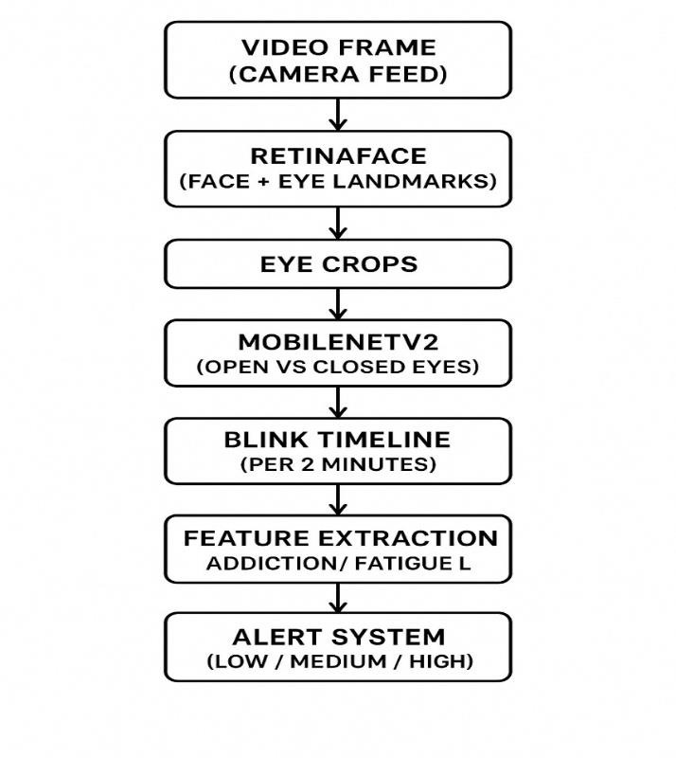
Figure.1

IX. SYSTEM DESIGN AND ARCHITECTURE

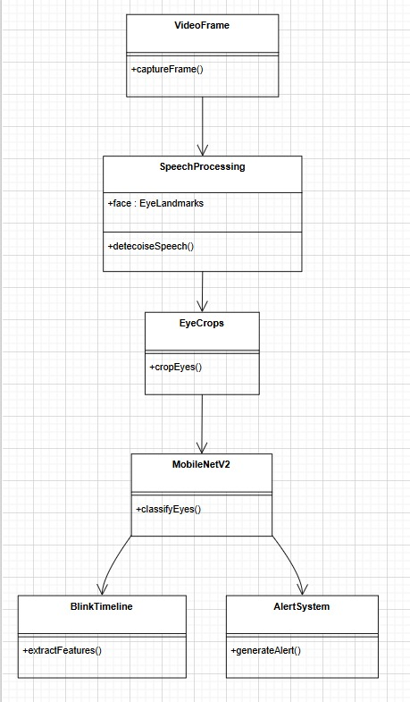
Figure.2

System design defines a complete pipeline of the inputs (real time video) and the output (smarterphone addiction level). The videoframe module comprises the beginning of the process which involves the continuous frame of the webcam of the user. The frames are forwarded to the Face Processing module where the RetinaFace recognizes the face and locates correct eye markings. The areas of the eye that are located are then forwarded to the EyeCrops component that isolates and cuts the area of the eye which will be subjected to further analysis. The MobileNetV2 model establishes the crops as an open or a closed eye state. These types form a series of time-serial that is analyzed by the BlinkTimeline module to obtain major blink features such as blink rate, blink duration and irregularity. Finally, the AlertSystem module would take into consideration the optimized features and provide a personalized addiction-risk alert (Low, Medium, or High), and provide the user with the immediate feedback. It is a structured design that is modular and enables appropriate detection, easy maintenance and real time monitoring without any difficulty.

X. ALGORITHMS USED

- RetinaFace
- MobileNetV2 CNN
- Multi-Layer Perceptron (MLP)
RetinaFace:Retina face is a face detection model which is very complex and operates in single stage where the face model is identified and the facial features are recognised within a real time scenario. RetinaFace is based on the RetinaNet architecture and employs contextual facial features and dense regression to offer high accuracy levels even in difficult circumstances such as low-light, partial occlusion, small face size, and different head poses.
Contrary to typical multi-stage-based detection systems (detect a face and then apply separate models to predict landmarks), RetinaFace conducts face and landmark localization in a single forward pass, and hence, requires much fewer computational resources. It determines major landmarks such as eyes, nose tip, corners of the mouth, etc. very precisely.

RetinaFace is a very important tool in this project to be able to accurately determine the face in every frame taken by the camera and determine the specific areas of the eye with landmark coordinates. These clarity cut eye patches are the basis of proper classification of eye conditions and RetinaFace is an important part of a powerful and effective blink-based tracking and addiction discovery.
MobileNetV2:MobileNetV2 is a gentle convolutional neural network model, which is optimised to be executed on mobile and other resource constrained devices and environments. It introduces two significant innovations inverted residual blocks, and linear bottlenecks that cause significant computational savings and maintain high precision. These design concerns allow MobileNetV2 to operate efficiently on smartphones and tablets and embedded systems without having to depend on a potent and powerful GPUs.
In the project, MobileNet V2 is used to classify all pictures of eye-region as an open or a closed picture. It is quick and efficient and can be applied in applications that require real-time with little delay between frame capture and prediction. The model uses every part of a cropped eye and gives the classification with a very low latency that helps measure eye behavior such as blink duration and blink frequency and has the ability of constantly observing eye behavior.
As smartphone addiction and fatigue monitoring have their foundation in real-time monitoring of eye movement pattern, the rate of high inference of MobileNetV2 is referred to the possibility to execute the task with ease and high accuracy, including, detecting a blink on the low-power devices.
Multi-Layer Perceptron (MLP):Multi-Layer Perceptron (MLP) is a type of computer-based artificial neural network; it comprises of numerous layers, one of which is an input layer, one or more hidden layers and an output layer. Each layer is characterized by nonlinear transformation with the help of the activation functions and it allows the network to learn complex relations between features and output classes.

The MLP classification used in the current project operates on the statistics features of blink which are extracted over a given time window i.e. such as:
- Average blink rate
- Maximum eye-open duration
- Variance in blink intervals
- Ocular stress in duration and intermittency of blink.
The traits are projections of physiological and cognitive trends of smartphone addiction or exhaustion. The MLP is conscious of the pattern of discrimination of these traits to classify the extent of addiction or fatigue of the user as low, medium, or high risk.
MLPs are also fast and efficient in their computation and hence can easily be used on mobile devices whose resources are few. The final decision making layer in the system is the MLP model which converts real time information of the blink into meaningful behavioural understanding with a high degree of accuracy.

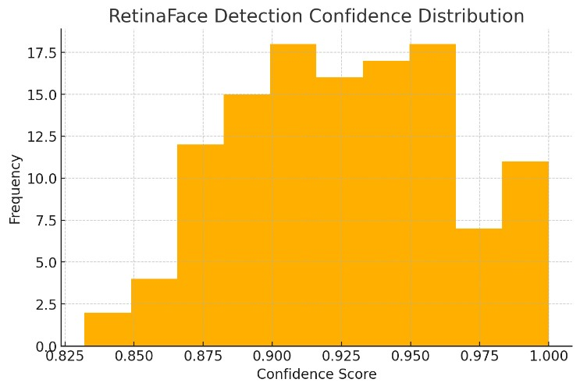
Figure.3
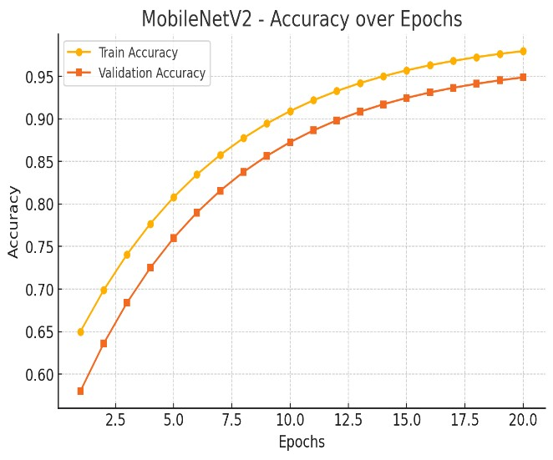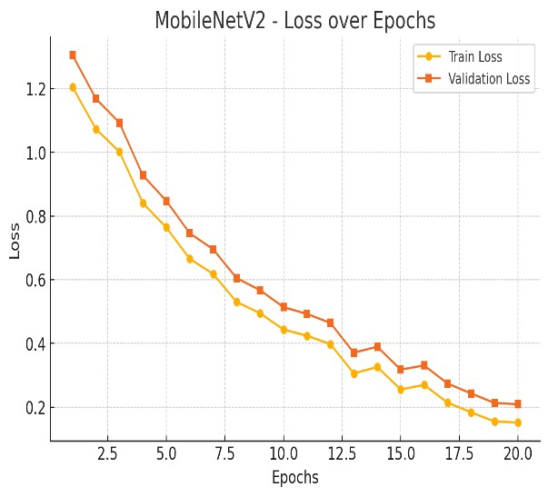

Figure.4 Figure.5
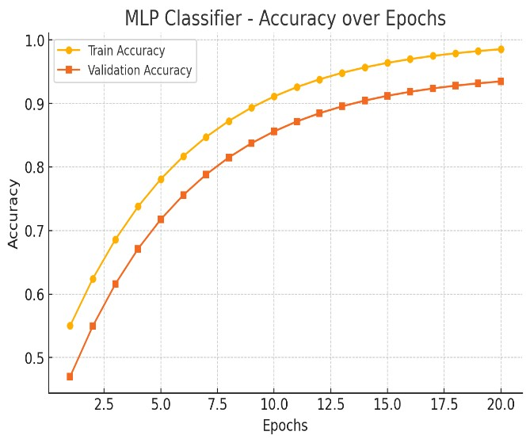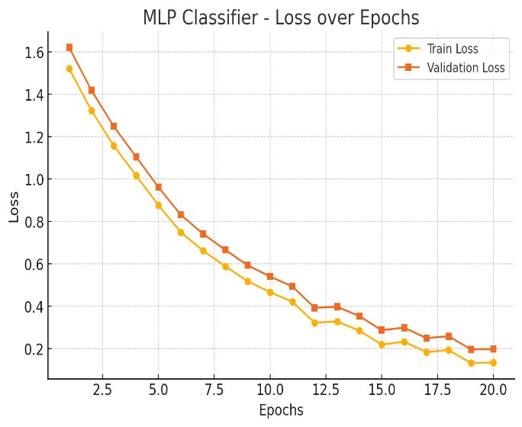
Figure.6 Figure.7

Final Accuracy Table
Model | Training Accuracy | Validation Accuracy
RetinaFace | N/A (not a classifier) | 0.93(avg detection confidence)
MobileNetV2 (CNN) | 0.98 | 0.95
MLP (Blink Features) | 0.99 | 0.93

RetinaFace Detection Model (retinaface)
Figure.3: Detection Confidence Histogram.
Distribution of shows scores of face detections.
The majority of the detections are between the 0.90 to 0.98 as this is an extremely high accuracy face detection.
MobileNetV2 (CNN Model)
Figure.4: Accuracy vs Epochs
Figure5: Loss vs Epochs
Study well: the closer to an epoch the better training and validation.
MLP Model (Blink Features)
Figure.6: Accuracy vs Epochs
Figure.7: Loss vs Epochs
Learns fast: low difference between learning and learning validation errors.

XI. RESULT AND DISCUSSION

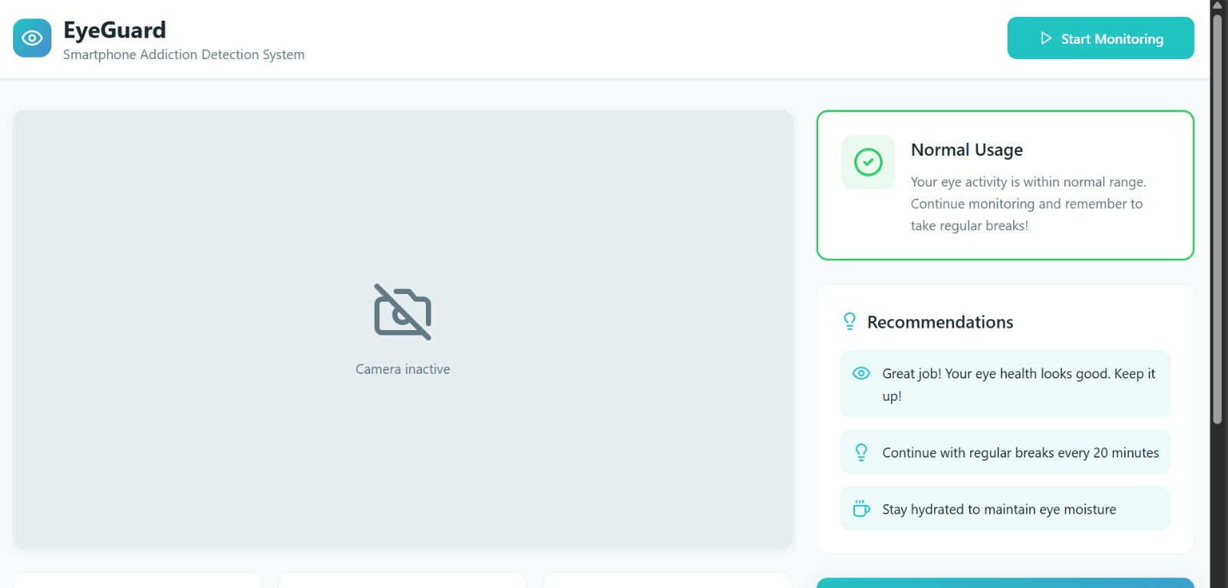
Figure.8

This character displays the first screen of the EyeGuard system in the default case when a camera is not active. The interface will show the primary monitoring zone, which will host the live camera feed after being switched on. The system displays the default status of Normal Usage and basic recommendation on the right side. No camera input is recorded, and therefore, the blink measurements, including Total Blinks, Blinks/Minute and Session Time are set to zero. The idleness of the application before it starts monitoring is illustrated in this screen.
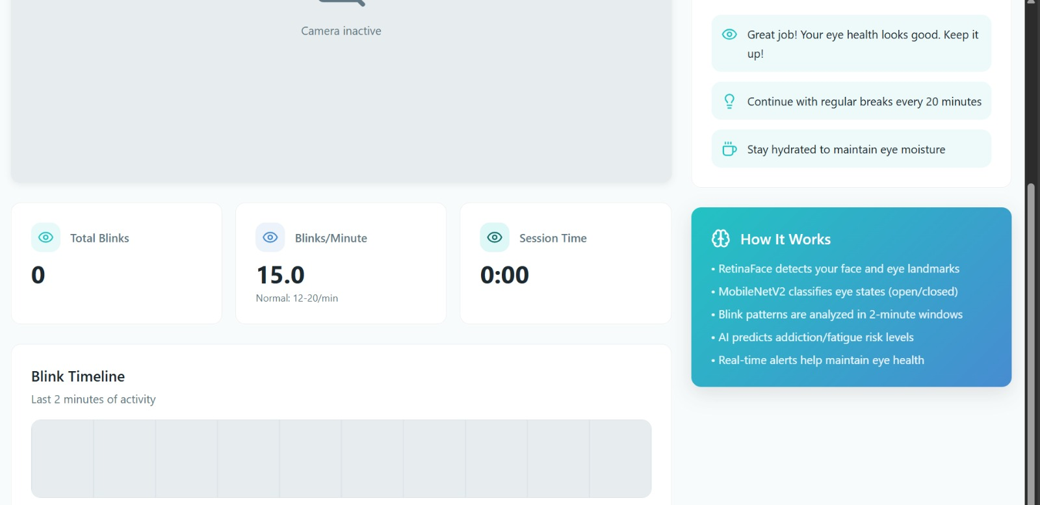
Figure.9

This figure determines the key performance indicators of the system since it is not available yet in terms of monitoring. The presented values (i.e. Total Blinks (0), Blinks/Minute (15.0 as default) and Session Time (0:00) refer to the base case. According to the graph Blink Timeline, no users have been active. This forms the starting point before the actual tracking can be set on.

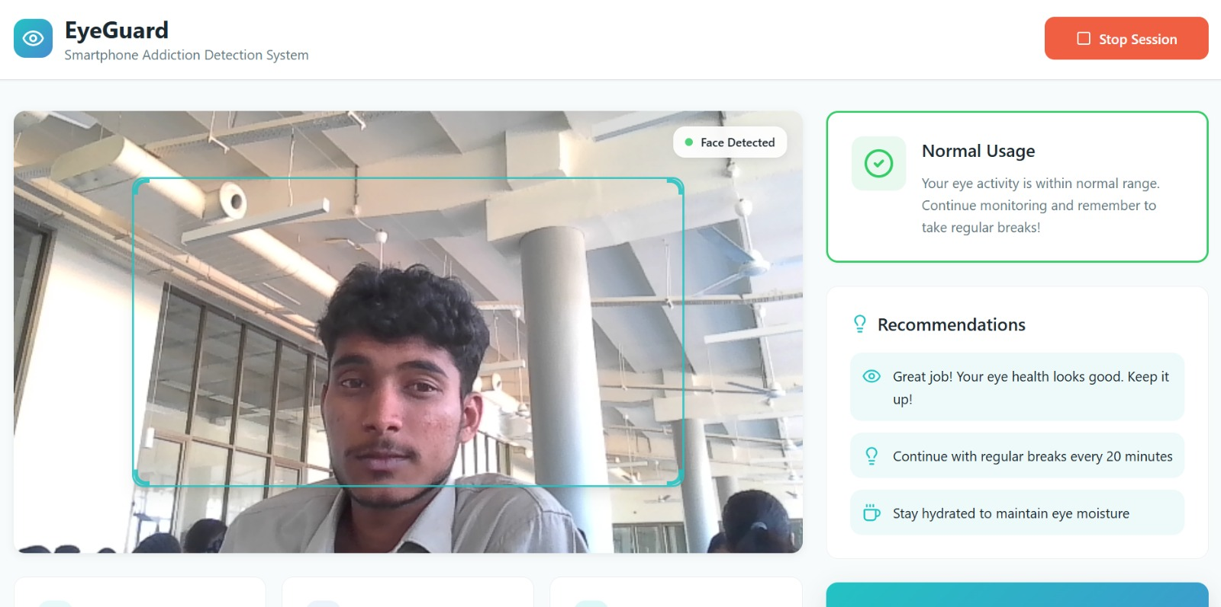
Figure.10
This figure presents the system when it is under active monitoring. RetinaFace manages to scan the face of the user and draw a bounding box of the face. This is confirmed by the system by a Face Detected indicator. Live suggestions are displayed in accordance with the blink activity. The fact that this visualization shows a face detection module is accurate and confirms the system is getting and analyzing video frames.

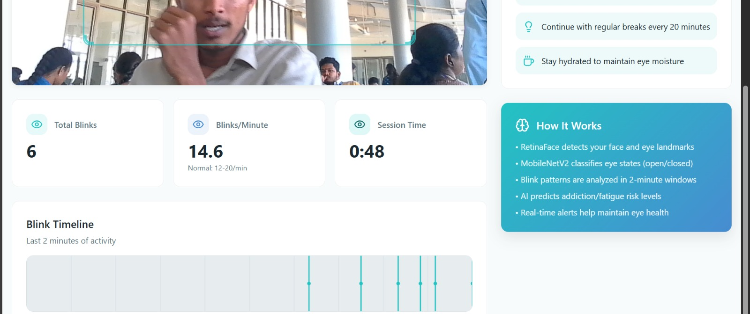
Figure.11

This figure indicates the real-time statistics of the system of blink. Total Blinks of the blink counter are 6, Blinks/Minute are calculated 14.6 (within the normal range) and Time of a session is 0:48 seconds. The Blink Timeline graph shows the frequency and distribution of the number of times that the blink took place in the past two minutes and how many times the blink took place. These steps indicate that the system is already in motion and it is monitoring the movement of the eyes and dynamically updated with the blink information.
This figure shows the informational panel elaborating in-house working of the system. Users are able to learn about the way RetinaFace identifies the eye landmarks, the way MobileNetV2 predicts the eye states, the analysis of the blink patterns, and the way the AI model predicts the level of risk. This boosts the transparency of the user and makes the technical operation of the model clearer.
This value represents the aggregated face detection output, blink monitoring output, recommendations output and real-time statistics. It also emphasizes the collaboration between the whole system to give an easy user experience. The interface validates the last prediction (Normal Usage) and also provides customized feedback to the users to ensure they manage healthy visual and digital habits.

XII. CONCLUSION

The developed system successfully predicts smartphone-induced fatigue by analyzing blink behavior using a deep learning–based pipeline, proving that eye activity is a strong and reliable indicator of digital overuse and cognitive tiredness. The integration of RetinaFace for highly accurate facial and eye landmark detection, MobileNetV2 CNN for classifying eye state (open or closed), and a Multi-Layer Perceptron (MLP) for fatigue level prediction enables the model to operate efficiently and non-intrusively in real time. Through continuous frame capture and preprocessing (grayscale conversion, histogram equalization, Gaussian smoothing, normalization, and resizing), the system extracts a clean and consistent Region of Interest (ROI) from the eye. MobileNetV2 then analyzes these eye crops frame-by-frame and classifies each as open or closed, after which blink patterns are observed over a sliding time window. Statistical blink-based features such as blink rate, blink interval variance, longest eye-open duration, and cumulative session duration are calculated and input to the MLP to determine fatigue levels (Low, Medium, or High). With 95% classification accuracy for MobileNetV2 and 93% fatigue prediction accuracy using MLP, the results confirm that automated blink monitoring is a dependable measurement of fatigue and attention decline during prolonged smartphone usage. The system’s high accuracy and real-time performance demonstrate its potential applications in digital wellness, safe driving alerts, online learning monitoring, workplace productivity, and preventive warning systems for eye strain and smartphone addiction. Overall, this project proves that deep learning combined with physiological visual cues can accurately detect fatigue without physical sensors or user interaction, offering a practical solution to promote healthier digital habits and reduce the negative effects of excessive screen exposure.

XIII.FUTURE SCOPE
The proposed algorithm of the digital wellness monitoring as the smartphone addiction prediction system is a solid starting point to do the real-time and can be significantly expanded in the future research. One of the main directions is the establishment of a complete Android and iOS application in a mobile version, which will provide the ability to track addictions constantly and on the phone without resorting to external mechanisms. With the introduction of this technology in phones it would see millions of users in the globe access digital wellness monitoring.
The other important enhancement to make in the future is the application of more advanced deep learning models such as LSTM, GRU or Transformer models. This type of model can make long-term dependencies on the blink patterns, with the help of which it is possible to make more exact and contextual forecasts regarding the level of addiction. This would also facilitate the system to be more accommodative to the different age groups, lighting and behaviors of the users.
Another area that is ready to grow is multimodal data fusion since the blink activity can be complemented with other signals of the user. It could be improved in the future to check head position, or pupil dilation, or facial expressions of stress, or even have data about smartwatches like heart rate variability or sleep patterns. A combination of a few physiological and behavioural signs would create a more complete and accurate diagnosis of digital fatigue and addiction.
The system can also evolve to a personalized digital wellness coach whereby the system will make personalized recommendations beginning with the behavior of the user. It may suggest the times of the breaks, the limitations of the screen time, or relaxation exercises and generate weekly/monthly reports about the eye health and attention improvement. This would contribute to transforming the system into a more of an active digital health assistant, opposed to a monitoring tool.
The second direction that is also significant in the future is the long-term behavioral analytics where the system will keep a history of trends and patterns over time. It would allow the user to understand the dynamics of growth in the degree of their addiction and, also, allow them to determine what factors make them more dependent on their smartphone.
Along with personal applications, the mental health monitoring has a high potential of the system as well as the stress, the cognitive load, and fatigue in the eye can be all associated with the rate of blinking and eye activity. The tool would be beneficial to mental health professionals as it would help in the early identification of the symptoms of anxiety, burnout, or depression.
The system could be implemented on a corporate level, such as in rising the productivity of the staff people who work long shifts in front of the screens; the system would be employed to identify the digital fatigue of the staff people. It can support organizations to be healthier by working and going digital.
Parental control applications can be listed among the most significant benefits to the society, as the system can help parents reveal the harmful tendencies of children and teenagers using the devices. This can be achieved by giving them timely warnings to guide them toward moderated screen time and prevent future troubles.
With little modification to the same eye-tracking pipeline, fatigue among drivers in cars can be detected so that road safety may be ensured by identifying drowsiness at a very early stage. The simple technology can be enabled to permit several real time monitoring applications in industries.
Finally, both the IoT devices and wearable technology can be linked to the future versions to receive more detailed and continuous physiological data. The integration of smart glasses, VR gadgets or internet of things health sensors can create a net of digital wellness devices all operating on the same simple deep-learning platform.

XIV.REFERENCES

[1]. J. Youwei, Real-time Eye Blink Detection using General Cameras: a Facial Landmarks
Approach, Int. Sci. J. of Engineering Agriculture, vol. 2, no. 5, pp. 1-8, 2023. isg-journal.com.
- V. Pothuraju, Raghavendra S, SantoshKumar Jankatti, and Rekha V, “Eye Blink Detection using CNN to Detect Drowsiness Level in Drivers for Road Safety,” Indonesian Journal of Electrical Engineering and Computer Science, vol. 22, no. 1, pp. 222-231, 2024.
ijeecs.iaescore.com.
- “Eye Fatigue Estimation using Blink Detection Based on Eye Aspect Ratio Mapping (EARM),” Cognitive Robotics, vol. 2, 2022, pp. 50-59. ScienceDirect.
- D. Kraft, F. Hartmann, G. Bieber, et al., “Camera-based Blink Detection using 3D-
Landmarks,” in Proc. iWOAR ’22: 7th International Workshop on Sensor-based Activity Recognition and AI, Rostock, Germany, Sept. 2022. ACM Digital Library .
- A. Jiman, A. Abdullateef, A. Almelawi, K. Yunus, Y. Kadah, A. Turki, M. Abdulaal, N.
Sobahi, and Eyad Attar, “Intelligent standalone eye blinking monitoring system for computer users,” Journal of Eye Movement Research, vol. 17, no. 5, 2024. bop.unibe.ch .
- Performance Evaluation of Image Processing Algorithms for Eye Blink ing Detection, Measurement, vol. 223, Dec. 2023, Article 113767. ScienceDirect .
- P. Govardhane and M. Wyawahare, “An Eye Blink Detection System for Dry Eye Syndrome and Its Performance Model,” in Ambient Commu nications and Computer Systems, Advances in Intelligent Systems and Computing, vol. 696, Springer, 2018, pp. 475-484. SpringerLink. [8]Hong, Y., Rong, X., & Liu, W. (2024). Construction of influencing factor segmentation and intelligent prediction model of college students' cell phone addiction model based on machine learning algorithm. Heliyon, 10(8).
- Likhith, S., Chitteti, C., Dharani, M., Nivedhitha, V., Geethika, N. G., & Godwin, V. (2024, April). Machine Learning Model for Prediction of Smartphone Addiction. In 2024 International Conference on Expert Clouds and Applications (ICOECA) (pp. 924-929). IEEE.
- Giraldo-Jiménez, C. F., Gaviria-Chavarro, J., Sarria-Paja, M., Bermeo Varón, L. A., Villarejo-Mayor, J. J., & Rodacki, A. L. F. (2022). Smartphones dependency risk analysis using machine-learning predictive models. Scientific Reports, 12(1), 22649.
- Lee, J., & Kim, W. (2021). Prediction of problematic smartphone use: A machine learning approach. International journal of environmental research and public health, 18(12), 6458. [12] Kim, K., Yoon, Y., & Shin, S. (2024). Explainable prediction of problematic smartphone use among South Korea's children and adolescents using a Machine learning approach. International journal of medical informatics, 186, 105441.
- Joseph, C., & Maheswari, P. U. (2025). Facial emotion based smartphone addiction detection and prevention using deep learning and video based learning. Scientific Reports, 15(1), 18025.
- Beluli, A. (2023). Machine Learning-Based Prediction Model for the Measurement of Mobile Addiction. In Designing and Developing Innovative Mobile Applications (pp. 56-66). IGI Global.

